**The "Tools" menu**

Wireshark supports several types of syntax, including Cisco IOS standard and extended ACLs, IP Filter, IP Firewall, Net Filter, Packet Filter, and Windows Firewall. Selecting **Cisco IOS (extended)** offers several levels of granularity: we can filter the source or destination host, TCP port, or both. Additionally, we can toggle the **Inbound** switch to swap source and destination addresses, and the **Deny** switch to toggle between permit and deny actions.

Now click on Tools> Firewall Rules:

The following dialogue appears:

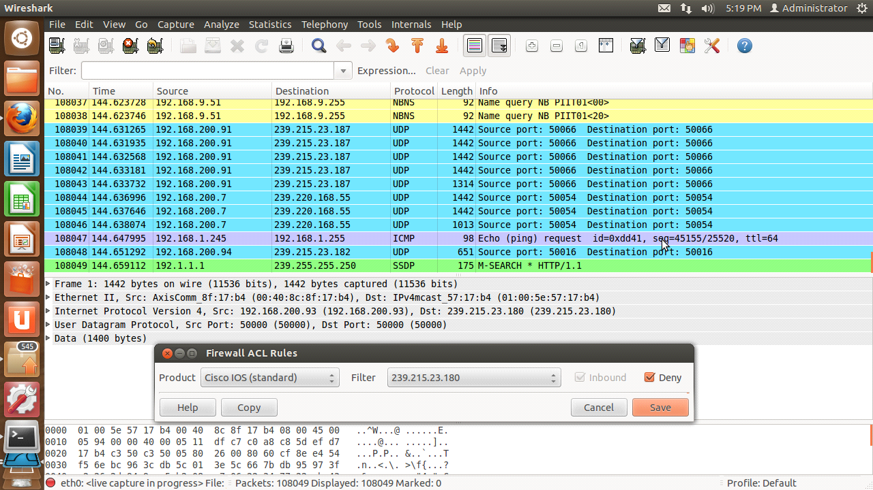

Note the default is Cisco IOS standard, and that the access list command syntax has appeared in the main window.

Note that Inbound traffic is default.  Also note that Deny is default.

Click on the "Product" down arrow to see the product types supported:

